82.09.07
From Otto Tepper
RB MSS M39, Library, Royal Botanic Gardens Melbourne.

Clarendon, 7.9.82.
Hochverehrtester Herr Baron!
Mit dieser Post beehre ich mich einige Orchideen im frischen Zustande zu senden, wovon zwei noch nicht identifizirt sind. Pterostylis curta unter deren Namen die erste, 85. mit einbegriffen war, ist zum Vergleiche beigelegt.
1) No. 85. Moist gully, hillside, among grass under trees, rich soil, no scrub as underwood; social, but very local; 2-5 inches high; one-flowered, large upper sepal & petal very much curved downward; rich green with white interspaces; broad marginal part of petal and labium brown; latter long narrow not projecting beyond slit of lower sepal; projection at base broad, brush-like, not sensitive. Stem very stout; with 2 large leaf-like scales; radial leaves large, oval, almost sessile, petiole with broad wings; generally 5 or 4 & a basal scale; tuber compressed, roundish, irregular; 2-3 inches deep.
874. Pterostylis sp. On steep grassy bank of hollow, hillside; rare social, only 3 specimen found flowering. Tuber small, round, compressed, regular; depth 1½ inches. Radical leaves 4 or less; one specimen found with 5; petiole long; wingless; leaf oval, same length as stalk; 2 larger, remainder smaller; Stem 6-9 inches slender, with 3 small, adpressed scales. Flowers small, one on each plant; lower part white with green ribs, shading into dark brown beyond the bend; curve less than right angle; appendages to lower sepal long & twisted. 6.9.82.
875. Boletus, Mt Bold, zwischen Grass auf nassem reichen Boden.
876. Flechten an alten dürren Baumstämmen.
877. Im tief. Sande im Scrub, nur auf einer Stelle bisher gefunden, niedriger Strauch 5-8 Zoll hoch; nicht häufig.
Von Pilzen habe ich bis jetzt 42 Arten gezeichnet u. könnte fast täglich neue Arten hinzufügen, wenn — es die Zeit erlaubte.
Meinen besten Dank für Ihre letzte freundliche Zusendung. Die Corysanthes (?) species, 878, kommt mir als verschieden von C. pruinosa vor u. habe ich dieselbe nur in der angemerkten Lokalität gesehen.
Mit ergebenstem Grusse verbleibe ich, Hochverehrtester Hr. Baron,
Ganz der Ihrige
J. G. Otto Tepper

Clarendon, 7.9.1882.
Highly esteemed Baron,
With this mail I do myself the honour of sending some live orchids of which two are not yet identified. Pterostylis curta under which name the first one, 85, was included, is enclosed for comparison.
1) No. 85. Moist gully, hillside, among grass under trees, rich soil, no scrub as underwood; social, but very local; 2-5 inches high; one-flowered, large upper sepal & petal very much curved downward; rich green with white interspaces; broad marginal part of petal and labium brown; latter long narrow not projecting beyond slit of lower sepal; projection at base broad, brushlike, not sensitive. Stem very stout; with 2 large leaf-like scales; radial leaves large, oval, almost sessile, petiole with broad wings; generally 5 or 4 & a basal scale; tuber compressed, roundish, irregular, 2-3 inches deep.
874. Pterostylis sp. On steep grassy bank of hollow, hillside; rare social, only 3 specimens found flowering. Tuber small, round, compressed, regular; depth 1½ inches. Radical leaves 4 or less; one specimen found with 5; petiole long; wingless; leaf oval, same length as stalk; 2 larger, remainder smaller; Stem 6-9 inches slender, with 3 small, adpressed scales. Flowers small, one on each plant; lower part white with green ribs, shading into dark brown beyond the bend; curve less than right angle; appendages to lower sepal long & twisted. 6.9.82.
875. Boletus, Mt. Bold, amongst grass on wet rich soil.
876. Lichens on old dead tree trunks.
877. In deep sand in the scrub, so far found only in one location, low shrub 5-8 inches high; not common.
I have until now drawn 42 species of fungi and could add new species almost daily, if — time would permit.
My sincere thanks for your last kind consignment. The Corysanthes (?) species, 878, appears to me different from C. pruinosa and I have seen it only in the indicated locality.
With most devoted greetings I remain, highly esteemed Baron,
Completely Yours,
J. G. Otto Tepper

Boletus
Corysanthes pruinosa
Pterostylis curta

MS found with a specimen of Corybas sp. (MEL 1851621) coll. Tepper, No. 878, Clarendon, Steep Gully, SA. MS annotation by M: 'Zieria veron.' [i.e. Zieria veronicea].
Marginal annotation by M beside this entry: 'Pterostylis'.
SA.
Near Clarendon, SA.
The pencil sketch by Tepper of this specimen (numbered '875' and 'A35') is in RB MSS A51, Library, Royal Botanic Gardens Melbourne: 82-09-07_image01.jpg The maximum width of the sketch itself is 5.4cm. Pencilled addition (by M?): 'Scleroderma'. 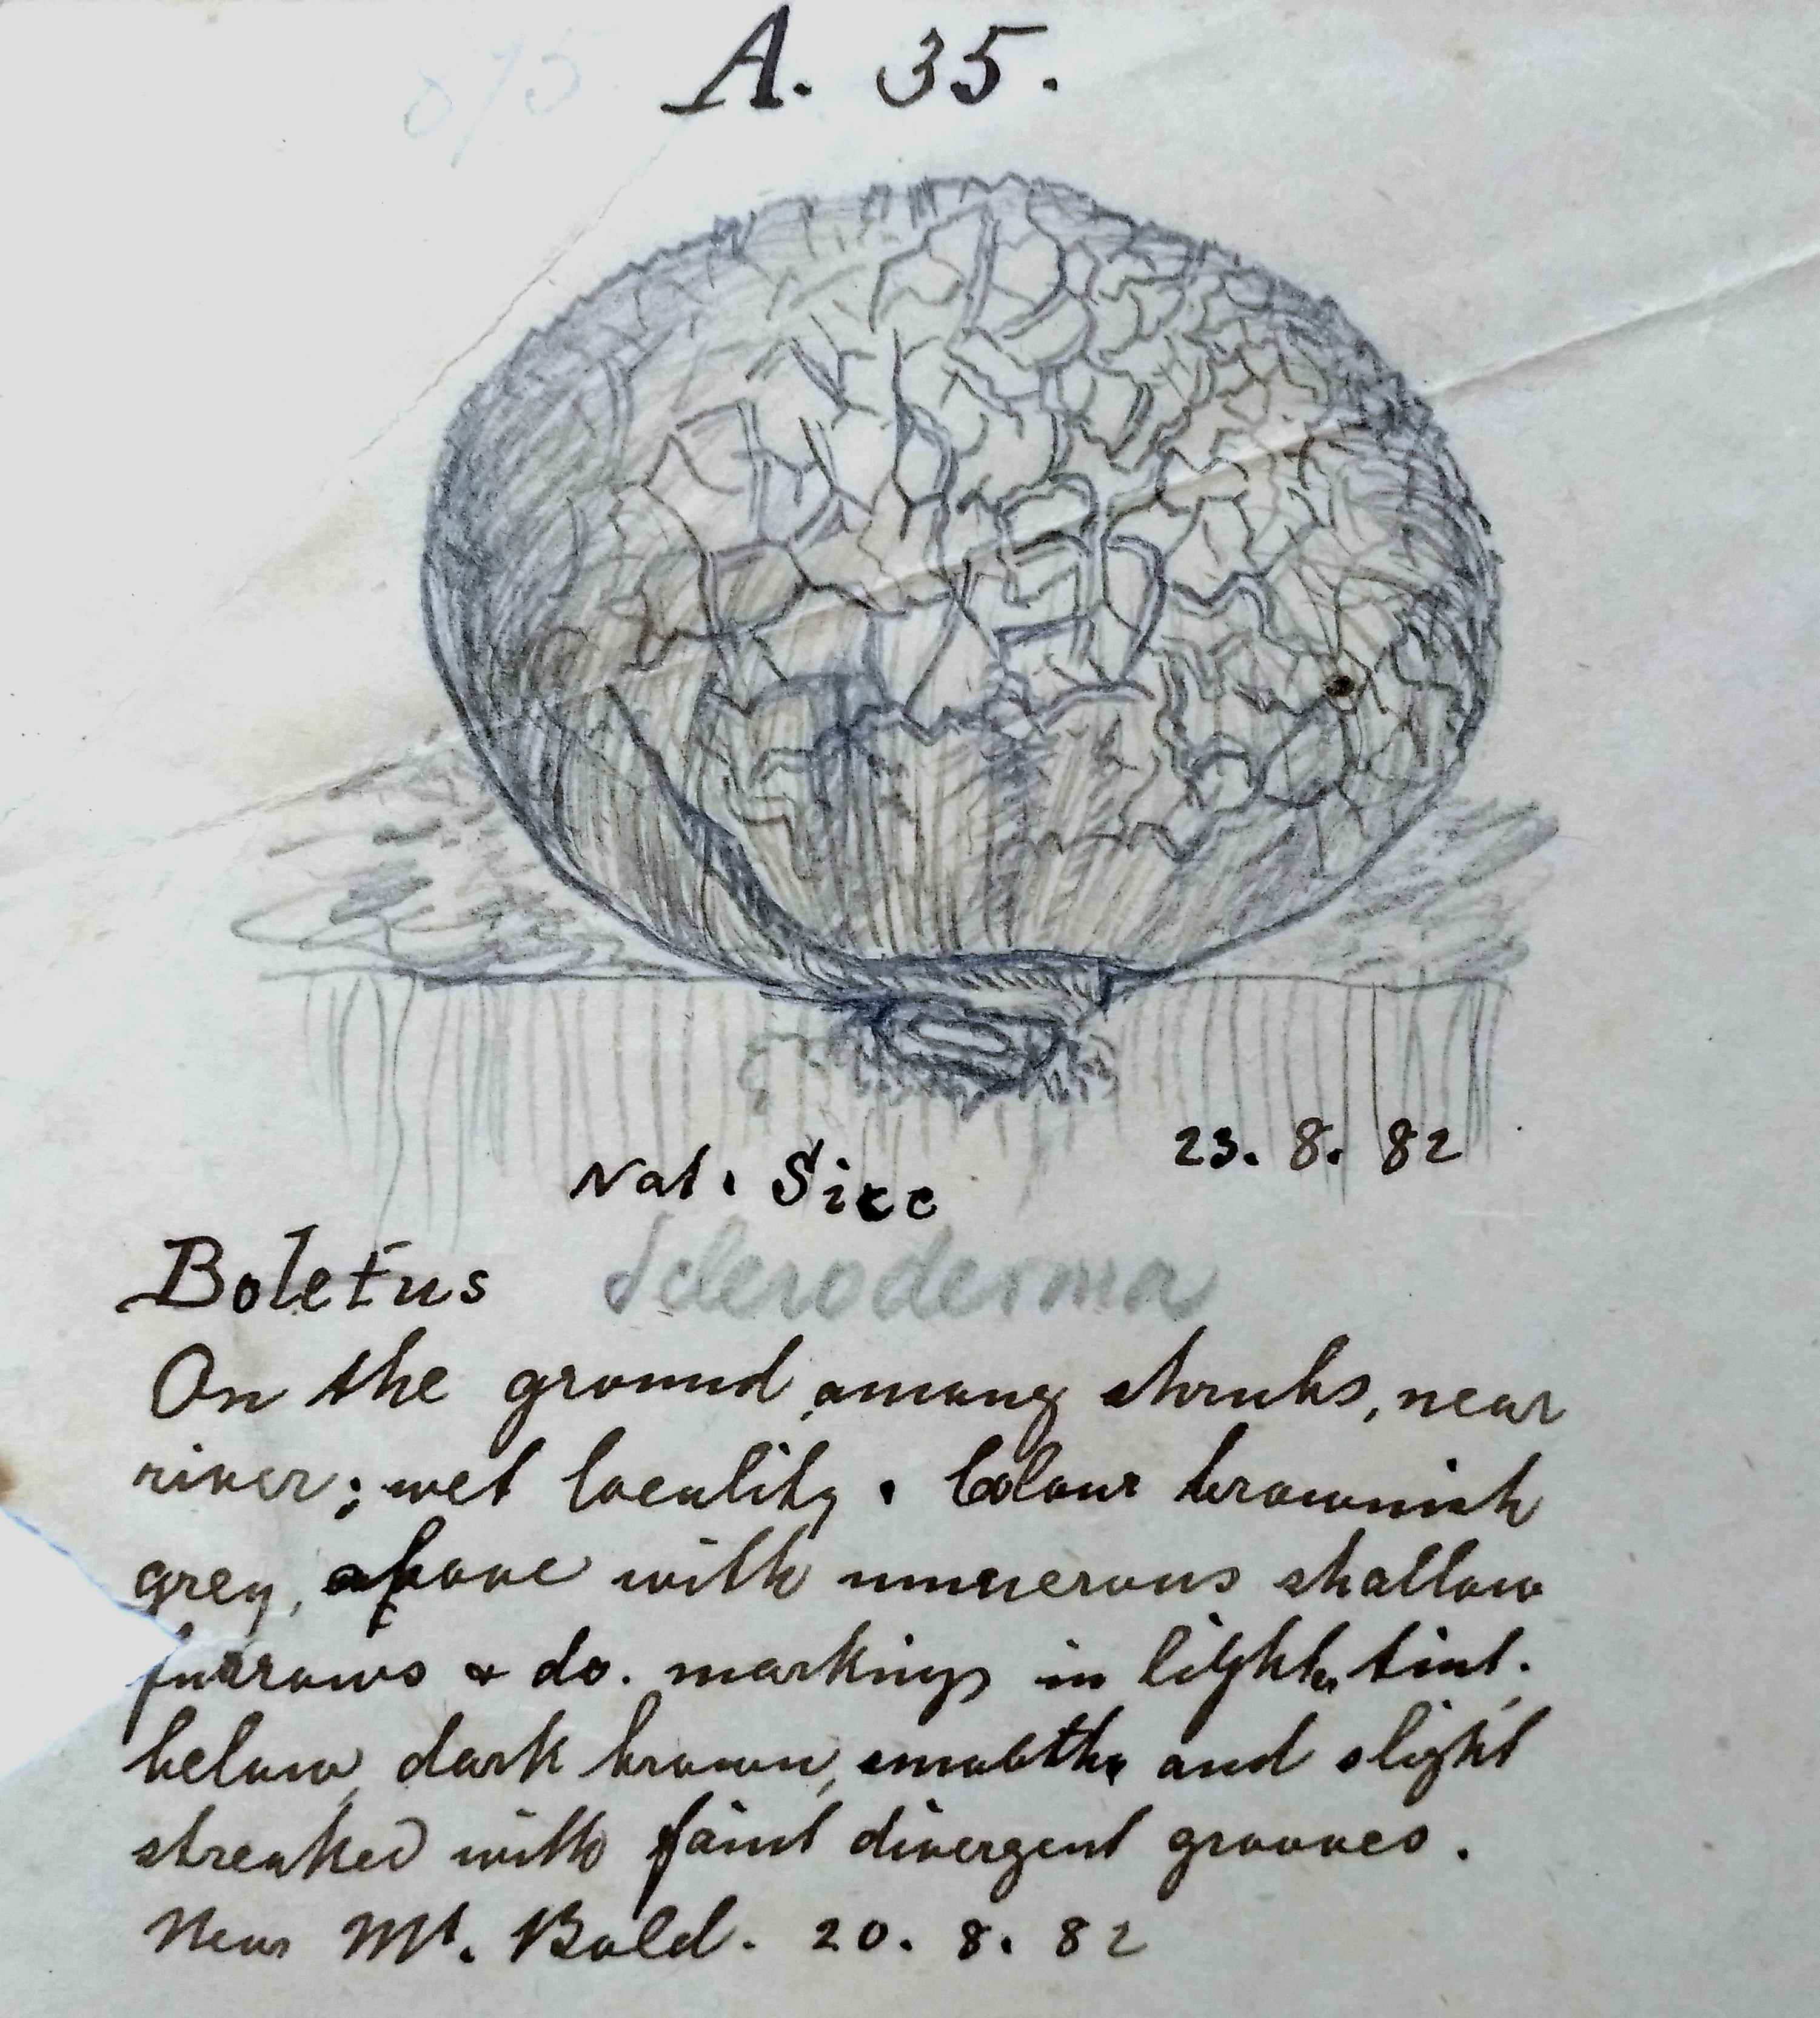
For M's reply, see M to O. Tepper, 12 September 1882 (in this edition as 82-09-12a).

